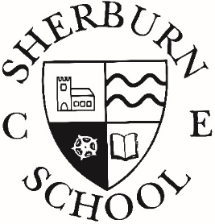
School Dinner Menu
Winter Term 2022

Week 1 | Week 2 | Week 3
Separate Main Meal option  Jacket Potato & Cheese | Separate Main Meal option  Jacket Potato & Tuna | Separate Main Meal option  Jacket Potato & Beans
Monday | Monday | Monday
Cheese & Tomato Pizza  Sauté Potatoes  Peas & Sweetcorn  Chocolate Crunch | Pasta Bolognaise  Green Beans & Sweetcorn  Garlic Bread  Oat Cookies & Sultanas | Chicken Korma & Rice  Cauliflower & Green Beans  Naan Bread  Chocolate Sponge & Custard
Tuesday | Tuesday | Tuesday
Chicken & Broccoli Pasta Bake  Carrots & Green Beans  Garlic Bread  Cheese & Crackers | Chicken & Vegetable Casserole  Baby New Potatoes  Mixed Veg & Cauliflower  Strawberry Yogurt & Summer Berries | Creamy Macaroni Cheese  Broccoli & Sweetcorn  Garlic Bread  Fresh Fruit Salad
Wednesday | Wednesday | Wednesday
Minced Beef & Yorkshire Puddings  Roast Potatoes  Mixed Veg & Sweetcorn  Peaches & Ice-cream | Pork Loin & Gravy  Mashed Potato  Carrots & Broccoli  Rice Pudding & Mandarins | Chicken in Gravy  Roast Potatoes  Carrots & Peas  Shortcake Biscuit
Thursday | Thursday | Thursday
Sausage & Gravy  Mashed Potato  Carrots & Broccoli  Sliced Bread  Apple Crumble & Custard | Quorn Dippers & Tomato Sauce  Potato Wedges  Peas & Sweetcorn  Chocolate Orange & Sponge & Custard | Nacho Beef Bake & Rice  Sweetcorn & Green Beans  Berry Sponge & Custard
Friday | Friday | Friday
Fish Fingers  Chips  Beans  Jam & Sponge & Custard | Breaded Salmon Portions  Chips  Beans  Flapjack | Battered Fish  Chips  Beans  Carrot Cake

Very occasionally due to circumstances beyond our control, it may be necessary to change from the menu
DISHES AND THEIR ALLERGEN CONTENT – Wolds & Vale Federation
 |  | DISHES  (with allergens) |  | 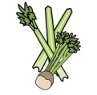 | 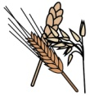 | 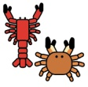 | 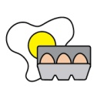 | 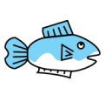 | 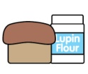 | 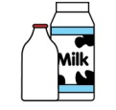 | 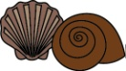 | 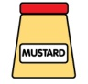 | 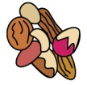 | 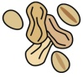 | 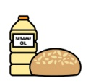 |  | 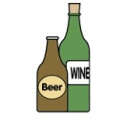
 |  | The foods below are some or all of the menu items for each day. Unlisted items do not contain identified allergens. |  | Celery | Cereals containing gluten | Crustaceans | Eggs | Fish | Lupin | Milk | Mollusc | Mustard | Nuts | Peanuts | Sesame seeds | Soya | Sulphur Dioxide
Week 1 | Mon |  | Cheese & Tomato Pizza
 |  |  | Chocolate Crunch
 | Tue |  | Chicken & Broccoli Bake
 |  |  | Cheese & Crackers
 | Wed |  | Minced Beef & Yorkshire Pudding
 |  |  | Peaches & Ice-Cream
 | Thur |  | Sausages & Gravy
 |  |  | Apple Crumble & Custard
 | Fri |  | Fish Fingers
 |  |  | Jam & Sponge Custard
Week 2 | Mon |  | Pasta Bolognaise
 |  |  | Oak Cookies & Sultanas
 | Tue |  | Chicken & Veg Casserole
 |  |  | Strawberry Yogurt & Summer Berries
 | Wed |  | Pork Loin & Gravy
 |  |  | Rice Pudding & Mandarins
 | Thur |  | Quorn Dippers & Tomato Sauce
 |  |  | Chocolate Orange Sponge & Custard
 | Fri |  | Breaded Salmon
 |  |  | Flapjack
Week 3 | Mon |  | Chicken Korma & Rice
 |  |  | Choc Sponge & Custard
 | Tue |  | Creamy Macaroni Cheese
 |  |  | Fresh Fruit Salad
 | Wed |  | Chicken in Gravy
 |  |  | Shortcake Biscuit
 | Thur |  | Nacho Beef Bake & Rice
 |  |  | Berry Sponge & Custard
 | Fri |  | Battered Fish
 |  |  | Carrot Cake
 |  |  | Jacket Potato & Cheese
 |  |  | Jacket Potato with Tuna
 |  |  | Jacket Potato with Beans

